InSTAGRAM BOT



by

JAYESH JAIN

A Project-Report submitted in fulfillment of the requirements for the certificate of

INTERNSHIP AS PYTHON DEVELOPER

AILOGIX SOFTWARE SOLUTION PYT. LMT. INDORE.

2022

Approved by Swapnil Sharma

CEO

Date

AILOGIX SOFTWARE SOLUTION

Abstract

“InSTAGRAM BOT”

by

JAYESH JAIN

CEO : Mr. Swapnil Sharma

A Project Report presented on the automation of Instagram using Instagram bot, beginning with the development of the bot, and covering the additional features like message, comment, like automations etc.

# Table of Contents

List of Figures iii

Problem Statement iv

Scope of Project v

Acknowledgements vi

Design and Implementation iii

Chapter I:

MENU 1

Figure 1 2

FollowBack 3

Figure 2 4

Search Location 5

Figure 3 6

Hash tag 7

Figure 4 8

Send Message 9

Figure 5 10

Unfollow 11

Figure 6 12

Copy 13

Figure 7 14

Like 15

Figure 8 16

Code Snippet 17

Conclusion 18

Bibliography 19

Glossary 20

Thanks 21

# List of figures

Number Page

1. Menu 12
2. Follow back 13
3. Search Location 14
4. Hash tag 16
5. Send Message 17
6. Unfollow 18
7. Copy 21
8. Like 24

# PROBLEM STATEMENT

To be Active on Social media and maintain our business Following like Following-back our recent-Follower’s ,liking Posts ,Like Hashtags and etc

Since Time is Money so we Developed an Software to Automate these

Features Currently on Instagram.

# Scope Of Project

This Project Is Designed to Automate the Social networks of Business Individuals who don’t have time to Manage Their Social network-Accounts But Want to Manage their Business Followings and Also have Inbuilt Features To avoid Detection By the Social Network Security

The Social Media/Network That is used is Instagram and reach out all the target Features Required in it like Follow back recent Followers, liking Posts , Unfollowing a Feature Can be used at a Point of Time Also we Will use a Pyqt5 to develop the Ui version Of the same

**Features Specified :**

* Follow-Back recent Followers
* Like Posts of our Followers/Following
* To fetch Post According To location and like, comment on same
* To fetch Post According To Hashtags and like, comment on same
* To Send Message to every Follower’s and Following
* To Unfollow Non-Followers

**Goals yet to Be Accomplished :**

* Develop a GUI version for the same
* Add a Reply Option So Bot can Automatically Reply
* Automate The Bot so it can work on it own

# Acknowledgments

The author wishes to express sincere appreciation to Mr. Swapnil Sharma for their assistance in the preparation of this manuscript. In addition, special thanks to Mr. Mitesh Rengar whose familiarity with the needs and ideas of the class was helpful during the programming phase of this undertaking. Thanks also to the members of the Ailogix for their valuable support.

# DESign and Implementation

The Implementation of the Bot is Divided into 8 chapters which are explained Briefly on how it is Implemented, the bot is coded using Instagram API Wrapper which is an Open-Source Python Library

A Snippet of the design Of the Instagram Bot is added Below :

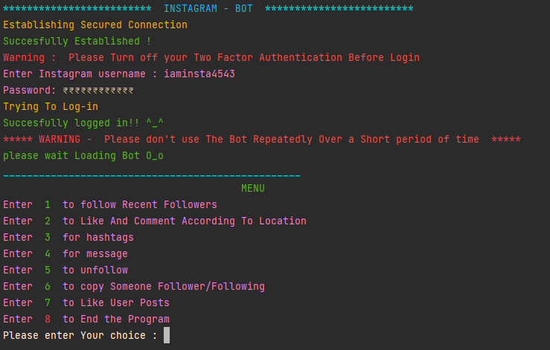

## Chapter 1

### MENU

When you feed credentials into the bot ,the bot try to login into your Instagram account , make sure your multi-factor authentication is turned off before login, after the bot is successfully Logged into your account It loads a Menu with the Option stated in the Flowchart ,where 1 Stands For FollowBack() it allow us to follow our recent Followers Deeply Explained in chapter 2 ,2 stands for searchLoaction() which takes longitude and latitude as input and allow us to like and comment as per our requirements Deeply Explained in Chapter 3, 3 stands for hashtag which allow us to fetch posts for a required hashtags and like, comment as per our Requirement deeply explained in chapter 4,4 stands for sendMessage() which allows us to send message to our Followers/Following as a group explained in chapter 5 ,5 stands for unfollow() which allow us to unfollow our followers and unfollowing explained in chapter 6, 6 stands for copy() which allows us to copy Followers/Following of any account explained in chapter 7, 7 stands for like() which likes the posts of all Messengers/Followers/Following thus increasing our reach explained in chapter 8, 8 stands for exit which ends the bot by logging out from our Instagram account

### Figure 1

### FollowBack

After entering 1 as input in the menu the followBack function loads which then start fetching our recent followers which is done by subtracting our followers from following if the difference of both is empty it says “No Recent Follower’s Found” than it checks for a file named “dont_delete_this_file.txt” this file contains user id’s of the account it has already followed if the file exists than it reads the user id’s from the file if the username matches with the current username than it reads the user id of already followed users and match them with new than it asks whether you want to request again to recent followers if you press “Y” than it removes the user id’s which are already present in the file thus preventing to send request again than it tries to follow recent followers it also let us know whether the account Followed is Private or Public and thus help in following recent Followers

### Figure 2

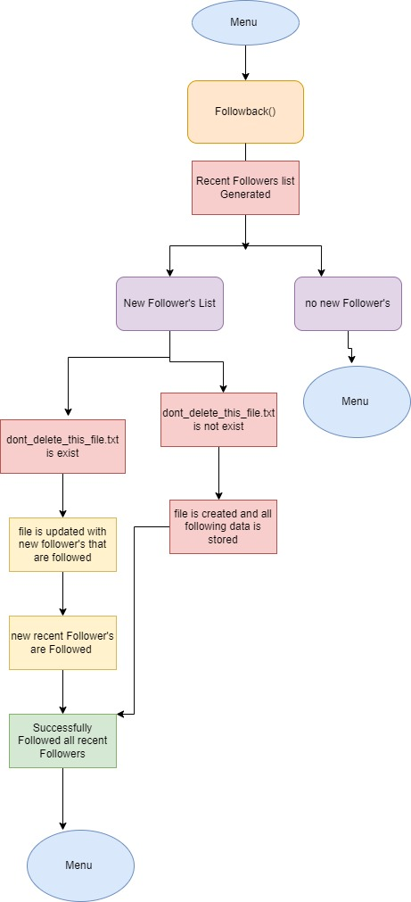

### Search Location

If you Enter 2 as input in the Menu the searchLocation() Function Loads and then it asks for longitude and latitude of a particular Place as per Your requirement than it searches for a location with the corresponding Place if no corresponding place is Found for the Entered Co-ordinates it says ” No Location Found For this Co-ordinates please try again with new- Co-ordinates if the location is Successfully Found for the corresponding Co-ordinates For eq if I enter 22.75,75.89 than it tries to fetch the Location For the corresponding Co-ordinates than it says “Successfully Fetched Location : Indore” than it asks how much posts we want to fetch for the entered Location the Maximum Limit is set to be 20 than it starts to fetch top posts for the entered Location After the Posts are Successfully Fetched it asks that whether you want to comment or not on the

Fetched Posts If you press “y” than it comments on random posts So that Instagram cannot detect if it’s a bot than it likes the post one by one and also comments on random Posts after it Likes all posts which are fetched than it send Back to bot

### Figure 3

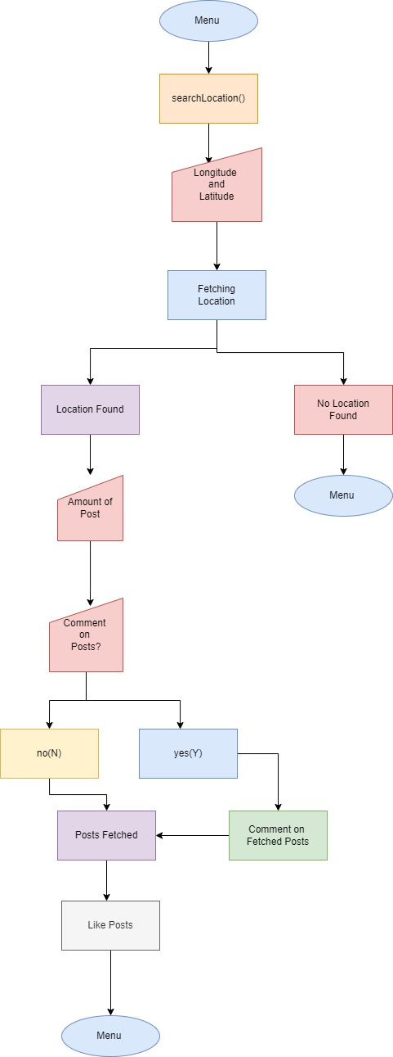

### Hashtag

If you Enter 3 as input in the Menu the hashTag() Function loads than it asks for a Collection of Hashtags separated by # after entering the Hashtags it asks for the number of hashtags that you want to fetch for each Hashtags the maximum limit set is 20 and minimum is 1 than it asks whether you want to comment or not on the posts the comments are completely random and made on random posts which prevent Instagram from detection than it starts Fetching Posts for the entered Hashtags if no Posts are Found for the entered Hashtags it says “Unfortunately No Posts Found For entered Hashtags” if the Posts are Successfully Fetched it starts Liking the Posts one by one if you have entered “y” when it asked for comments than it would also comment else it wouldn’t .

### Figure 4

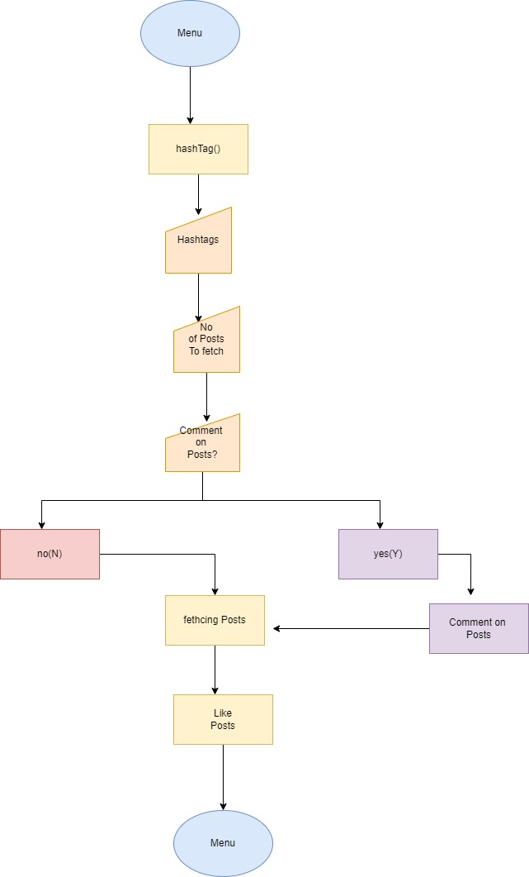

### Send Message

If you have entered 4 in the Menu than sendMessaage() function is Called which asks Whether You want To message all Followers/Following for Followers You need To Press 1 and for Following you need to press 2 if you enter anything Else than 1 and 2 than it says “ Wrong Input Please Try again!” and sends you back to menu than it creates a list of all usernames of all Followers/Following as entered By You than it asks For a Message that you want to send them after entering the Message than it let us know whom it is messaging and after the message is Successfully Sent it says Successfully Message sent after Messaging all Followers\Followings it says Successfully sent Message to all and then Loads the Menu again For Further Input

### Figure 5

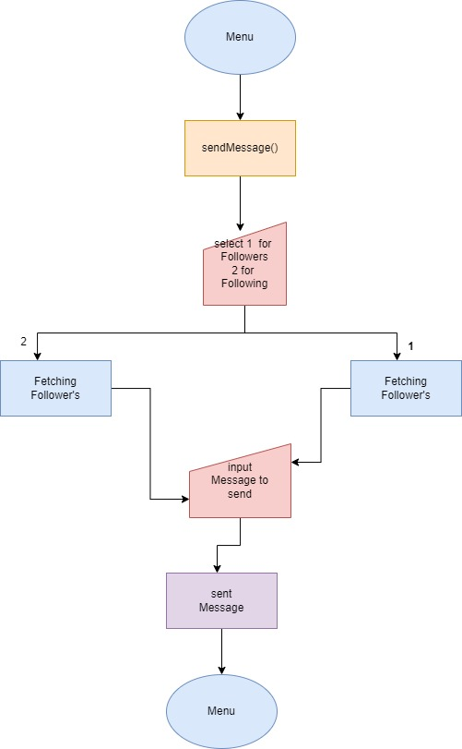

### UnFollow

If you enter 5 as Input in the Menu , than it asks For a Confirmation “are you sure You want to Unfollow “ don’t Worry this doesn’t Start unfollowing after Pressing Y here unfollow() Function Loads This function is made to unfollow Users thus Reducing Our time, after this it says Press 1 to Unfollow all non-Followers and 2 to Unfollow all Followers if you enter anything Other than that it says Wrong Input and sends You back to Menu if you press 1 it starts fetching all our Followers and if we press 2 it subtract our Following from Followers thus we get Non Followers than it shows the username who it is trying to Unfollow and after successful unfollow it says Successfully Unfollowed

### Figure 6

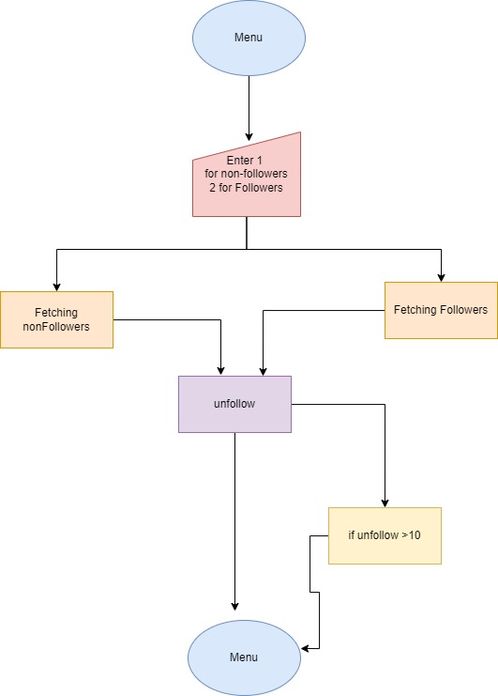

### Copy

If you Press 6 on the Menu the copy() Function loads this Function is basically Made to copy an Account Follower’s or Following the basic idea behind Making of this Function is that imagine you working for charity so if you know someone who is already working in this Field so you can copy his/her Followers/Following and can increase Your reach in respective Field. when the copy() Function Loads It asks for username or link of the profile whose username you want to copy after entering the link/Username of the account it tries to fetch the account to that username if no account is found it says “Sorry no Account found for entered Username/Link” if the account is matched for the username/link it says account Successfully Found, After the account is Successfully Found it says Press 1 to copy User Follower’s or Press 2 to copy User Following whatever you choose it starts Fetching Followers/Following and starts Following it The Maximum Limit set here is 10 after Following 10 users the copy function gets Terminated and sends the control back to menu

### Figure 7

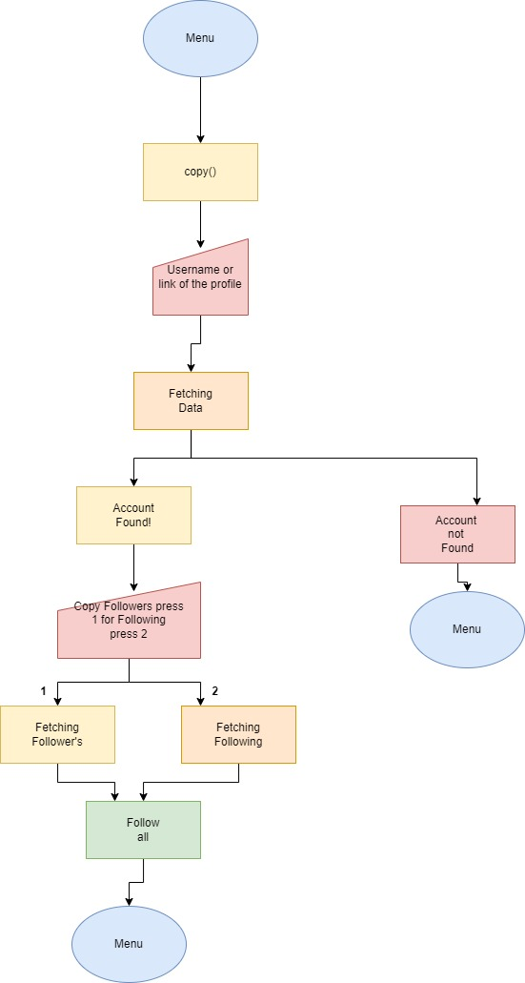

### Like

If you press 7 on the Menu like() function gets called this Function Is made to like user Post’s to make the account seem like real human and increase our reach when the like function loads it says enter 1 to like Posts of all Messengers ,2 to Like Post of all Followers ,3 To like post of all Following if you enter anything wrong It says wrong input Please try again than it starts Fetching The users as per your input once it has fetched all user’s it says Successfully Fetched than it Fetches the user Post’s and starts liking it one by one it fetches the recent Posts and like Posts the limit set here is 10 after Liking 10 posts of a user it than moves to the next person thus liking till all of them thus making our account more interactive

### Figure 8

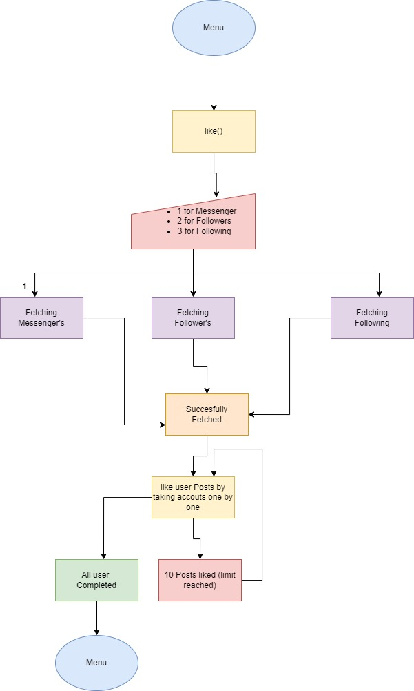

# Code Snippet

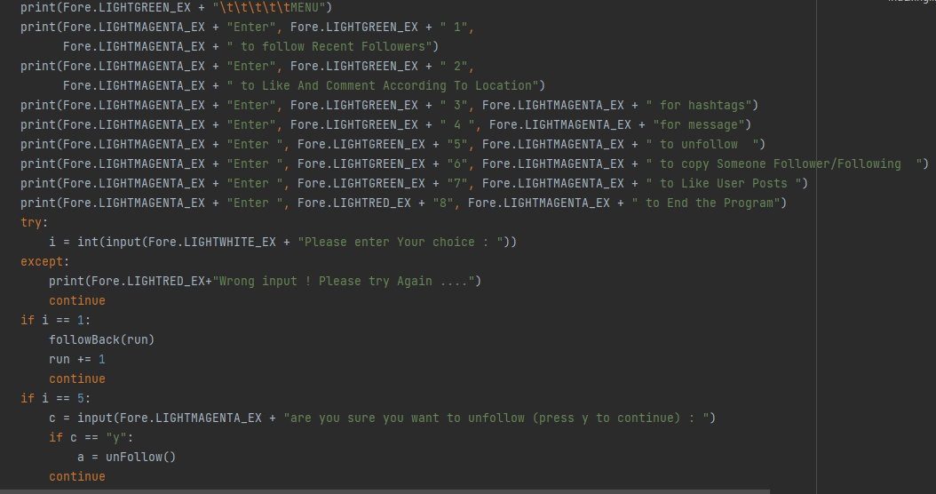

# Conclusion

In conclusion I would like to add the Features that we were able to embed in this Project Firstly the Instagram -Automation Bot ver 1.0.0 is coded on Instagrapi API Wrapper So the Bot is Fully coded In Python Language Firstly the bot Contains a Menu That has list of all the Features in it

The Features Present in the bot:

* Firstly it contains a Follow Back Option that allow us to follow-back our Follower’s which help in interacting with our Follower’s
* Secondly it has a Search Location that takes longitude and latitude as input and fetch Post for the location and like & comment on the same.
* Thirdly it has a hashtag option that takes List of Hashtags as input and fetch post for hashtag and like, comment on same
* Fourth it has a Send message that allow user to send Message to every Followers, Following thus Making it more interactive
* Fifth it has Unfollow option that allow user to unfollow non-Followers thus removing those following which are not interested
* Sixth it has Copy option that allows user to follow anyone Follower or Following
* Seventh it has Like option that allows user to like Post of every Follower’s, Following and Messenger thus, making it more interactive

# BIBLIOGRAPHY

Instagrapi Sep 2021

<https://github.com/adw0rd/instagrapi>

# Glossary

Instagrapi. A API to automate Instagram and inbuilt features like, comment, follow, messages, hashtag which is made on Python language.

Location. A combination of longitude and latitude for a specific point.

Hashtag. Inbuilt features of Instagram useful for categorize content and make it more discoverable.

**Two Factor Authentication**. It is a security feature that helps protect your Instagram account and your password.

Public. Your profile and posts can be seen by anyone, on or off Instagram, even if they don't have an Instagram account

Private. Only the followers you approve can see what you share.

**API.** stands for Application Programming Interface allows automation of anything.

Thank You